Terraform Task - 1
Terraform + AWS EC2 + GitHub + Jenkins

1). Install Terraform on the Linux Server
Terraform was installed on the AWS Amazon Linux server instead of Windows because the practical work was performed directly on an EC2 Linux machine.

Download and install Terraform
- Download the Terraform Linux AMD64 package for Terraform 1.16.1.
- Extract the Terraform archive.
- Place the terraform binary in a directory available in PATH.
- Verify the installation from the terminal.
terraform version
Verification: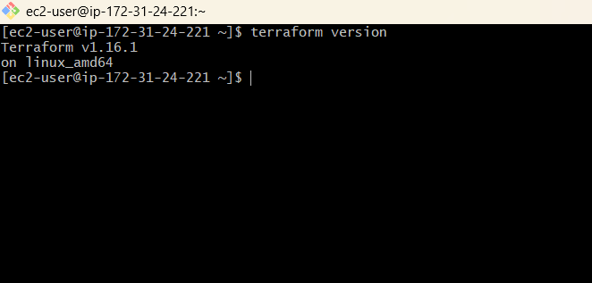
Terraform v1.16.1
on linux_amd64
Result: Terraform installation completed successfully.

2). Execute Terraform Templates

Create a Terraform practice directory
mkdir -p /home/ec2-user/terraform-practice
cd /home/ec2-user/terraform-practice

Create the Terraform configuration
The local_file example was created following the example used in the reference document.
resource "local_file" "pet" {
filename = "pets.txt"
content = "My Parents love pets!"
}

Terraform Init
Terraform init initializes the Terraform working directory and downloads the required provider.
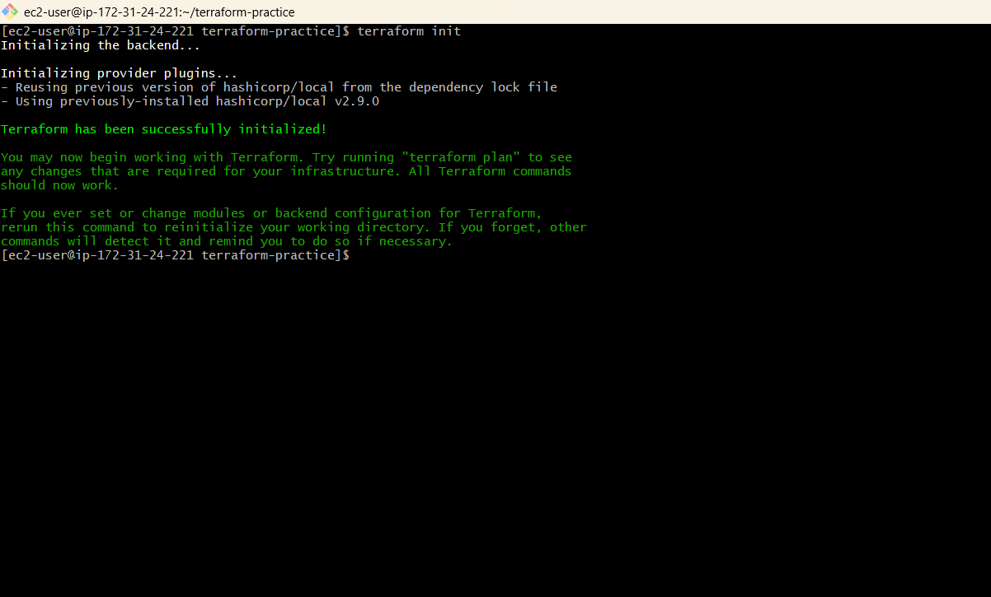
terraform init
Result: Terraform initialized successfully and the hashicorp/local provider was installed.

Terraform Plan
terraform plan
Result: Plan: 1 to add, 0 to change, 0 to destroy.
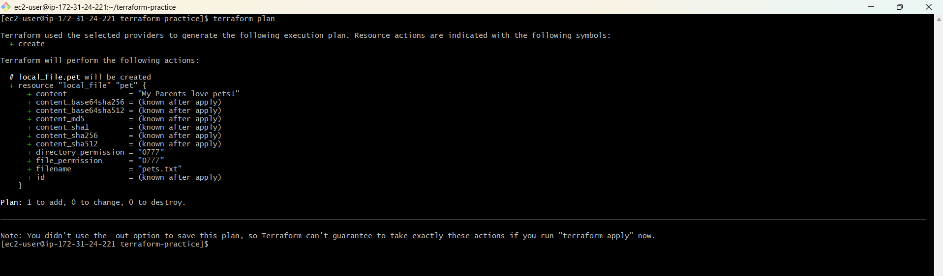

Terraform Apply

Terraform Apply
Terraform apply creates or updates resources according to the Terraform configuration.
terraform apply
When prompted, enter:
yes
Result:
Apply complete! Resources: 1 added, 0 changed, 0 destroyed.
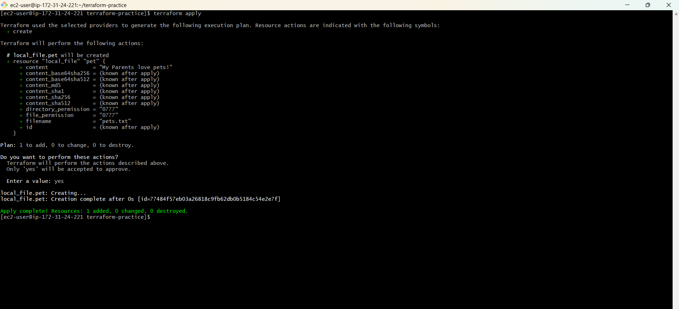

Verify the created file
ls -l pets.txt
cat pets.txt
Expected content:
My Parents love pets!
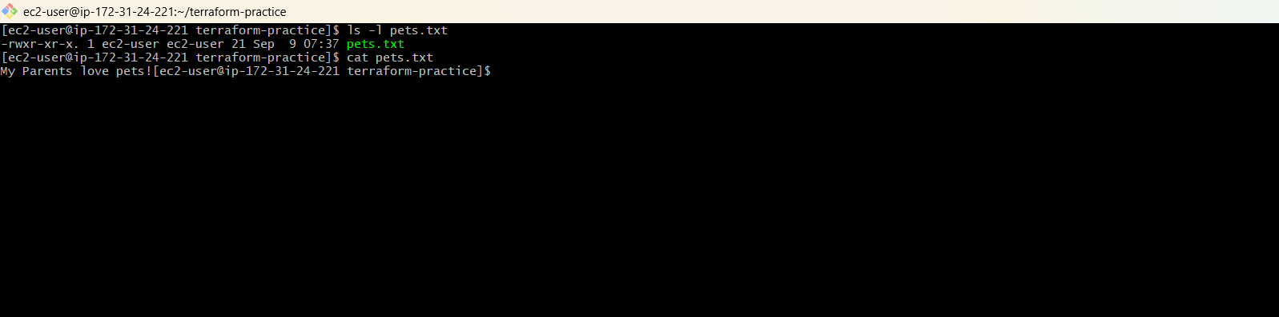
Result: The local file resource was created successfully.

Terraform Show, Destroy and Multiple Providers

Terraform Show
terraform show
The command displayed the Terraform-managed local_file resource and its state.
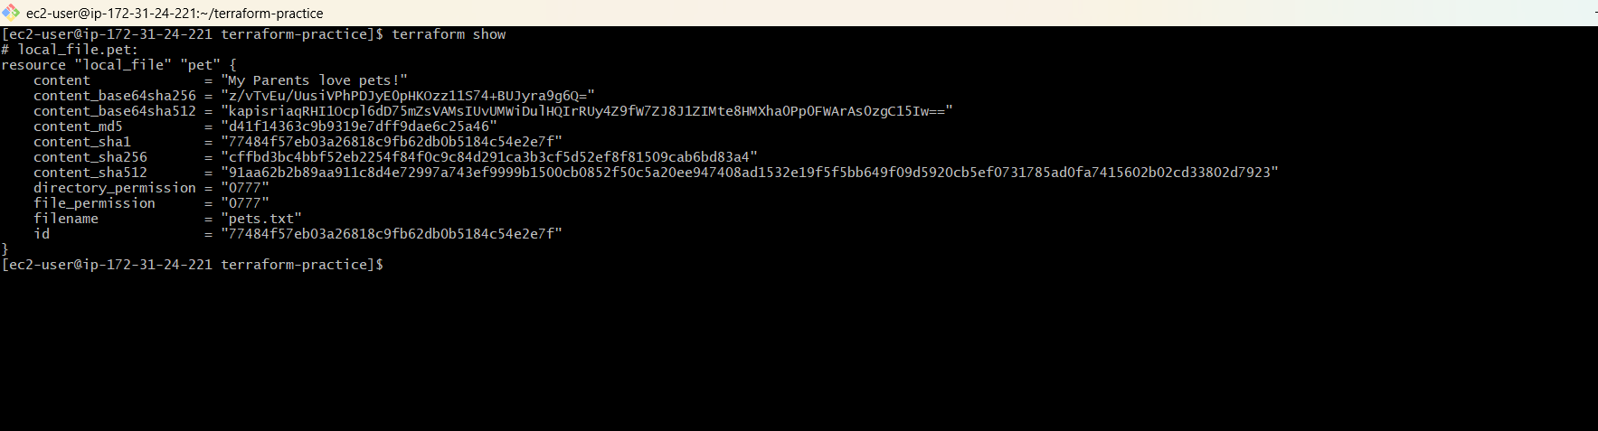

Terraform Destroy
terraform destroy
When prompted, enter:
yes
Result:
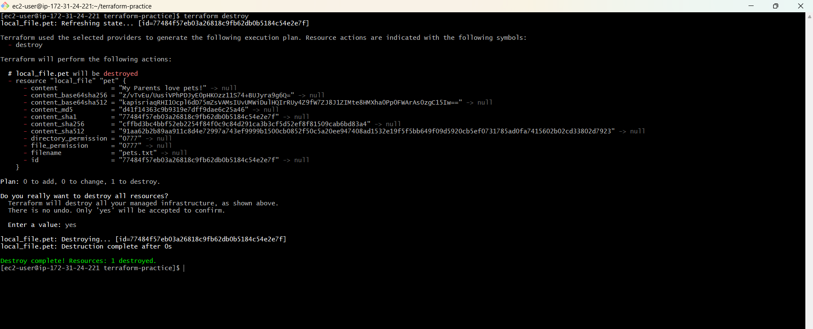
Destroy complete! Resources: 1 destroyed.

Multiple Providers
The reference document includes a multiple-providers section. The practical work then moved to the AWS provider for the Jenkins integration.
Note: No additional multiple-provider configuration was required for the final Jenkins/AWS EC2 pipeline.

Terraform Commands - Notes

3). Note down the important Terraform points
Command / Term | Purpose
terraform init | Initializes the Terraform working directory and downloads required providers/modules.
terraform plan | Shows what changes Terraform will make before creating or modifying resources.
terraform apply | Creates or updates resources according to the Terraform configuration.
terraform destroy | Deletes resources managed by the current Terraform configuration.
terraform show | Displays the current Terraform state and managed resources.
Terraform provider | A plugin that allows Terraform to communicate with a target platform such as AWS.

Practice Result
- The local_file resource was initialized, planned, applied, inspected, and destroyed.
- This confirmed that the basic Terraform workflow was working before moving to AWS.

Terraform Workflow

Basic Terraform Workflow
Terraform Configuration
↓
terraform init
↓
terraform plan
↓
terraform apply
↓
Resource Created / Updated
↓
terraform show
↓
terraform destroy
The same Terraform lifecycle was then applied to an AWS EC2 resource.

AWS Integration Preparation
- AWS CLI was installed on the Amazon Linux server.
- An IAM role named TerraformEC2Role was created.
- AmazonEC2FullAccess was attached to the role for the assignment.
- The role was attached to the practice/Jenkins EC2 instance.
- 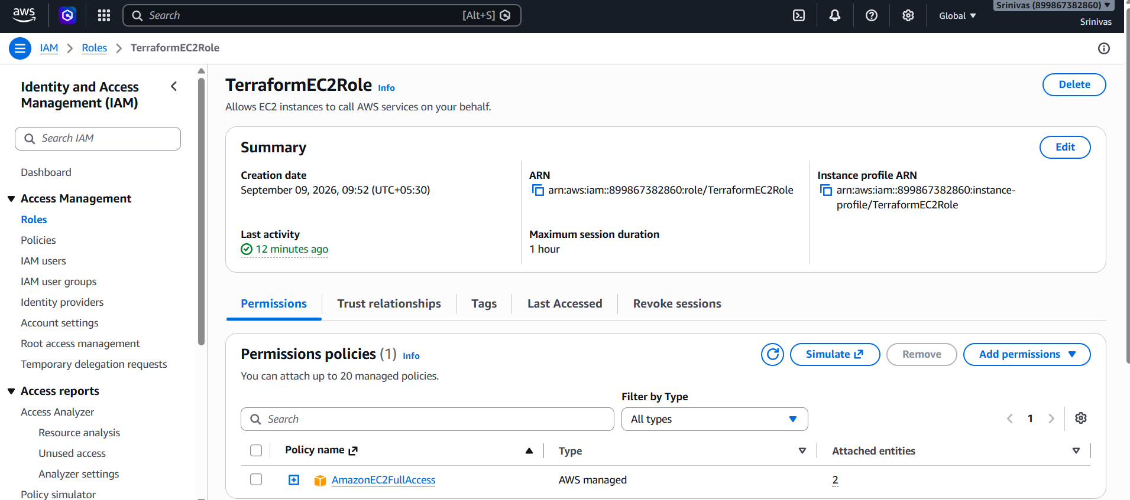
- 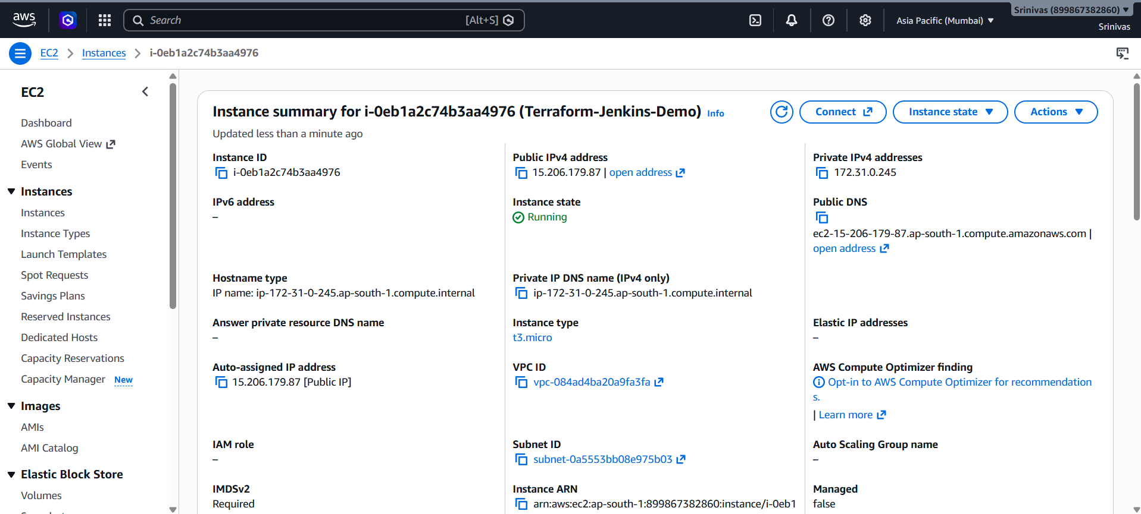

4). Integrate a Sample Terraform Template in Jenkins

Objective
Configure Jenkins to execute Terraform commands automatically.
GitHub
↓
Jenkins
↓
terraform init
↓
terraform plan
↓
terraform apply
↓
AWS EC2

Important
Terraform and AWS credentials must be available to the machine/agent running Terraform. In this practical setup, the North Virginia Amazon Linux EC2 server was used as the Jenkins server and also had Terraform, Git, AWS CLI, and the IAM role available.

Project
GitHub repository:
https://github.com/krishnasaiyalla6888-lgtm/Jenkins-Private-Repo
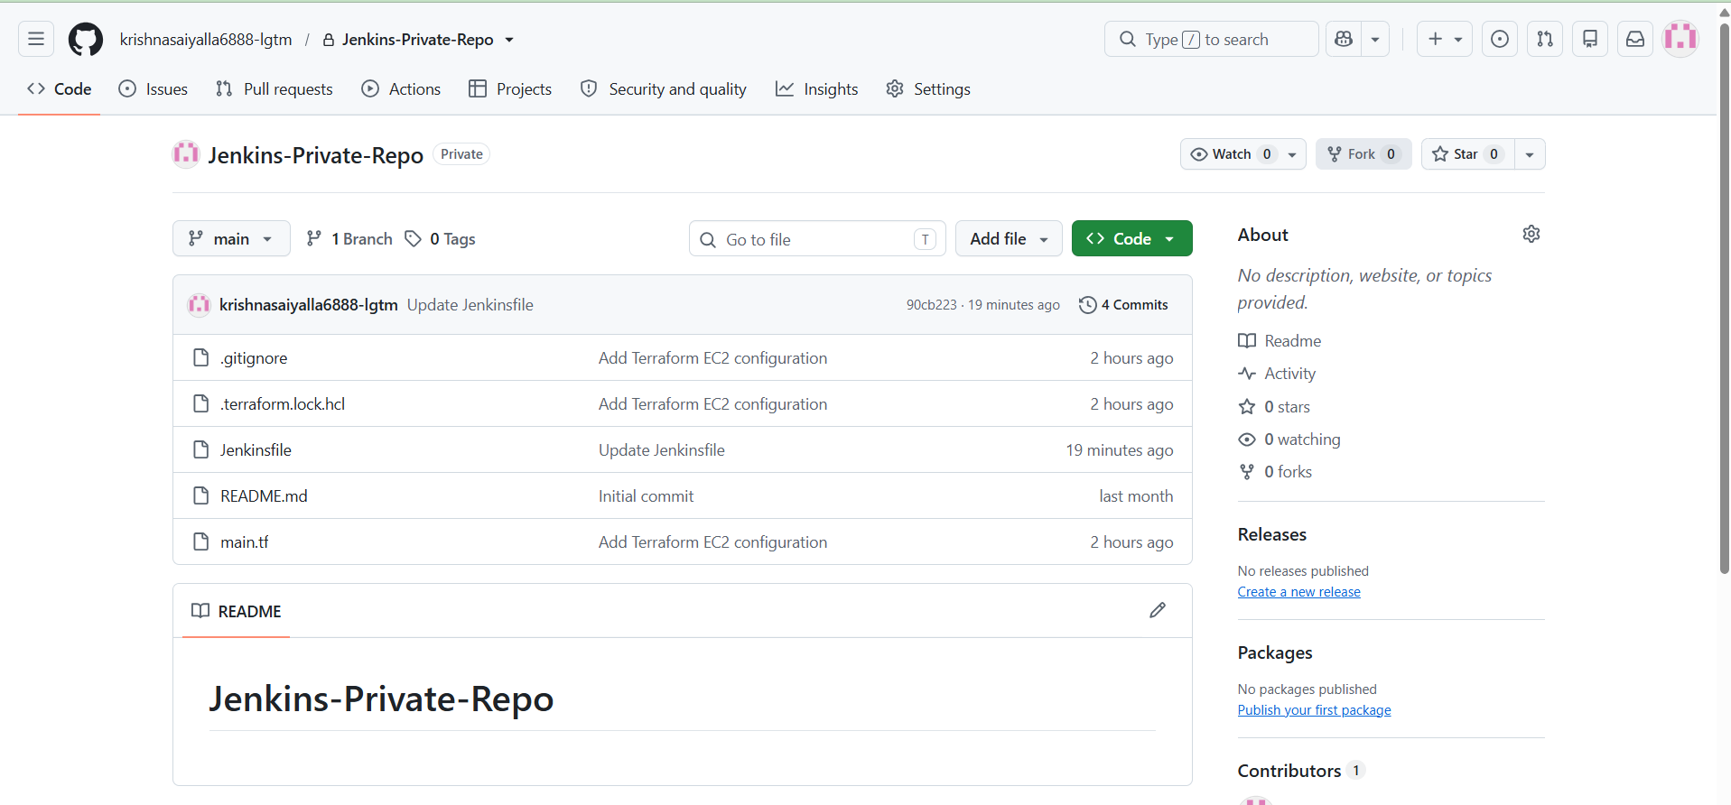

Step 1: Create Terraform Project

AWS CLI Verification
aws sts get-caller-identity
The command confirmed that the server was using the TerraformEC2Role IAM role.

Verify access to ap-south-1
aws ec2 describe-availability-zones --region ap-south-1 --query 'AvailabilityZones[0].ZoneName' --output text
ap-south-1a

Create project directory
mkdir -p /home/ec2-user/terraform-jenkins-demo
cd /home/ec2-user/terraform-jenkins-demo

Create main.tf

AWS Terraform Configuration
terraform {
required_providers {
aws = {
source = "hashicorp/aws"
}
}
}

provider "aws" {
region = "ap-south-1"
}

resource "aws_instance" "demo" {
ami = "ami-035827357e3c7e810"
instance_type = "t3.micro"

tags = {
Name = "Terraform-Jenkins-Demo"
}
}
The configuration follows the structure of the reference template, using the valid AMI used during the practical execution.
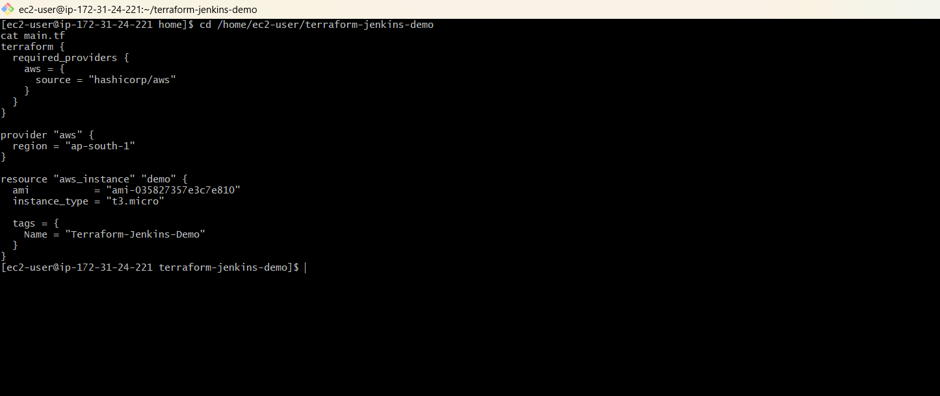

Step 2: Test Terraform Manually First

Initialize the AWS Terraform project
cd /home/ec2-user/terraform-jenkins-demo
terraform init
Result: Terraform initialized successfully and the hashicorp/aws provider was installed.

Create the execution plan
terraform plan
Result:
Plan: 1 to add, 0 to change, 0 to destroy.

Apply the configuration
terraform apply
When prompted, enter:
yes
Result: The AWS EC2 instance was created successfully.

Verify the AWS EC2 Instance

Terraform-created EC2
The EC2 instance created during the manual Terraform test was:
Property | Value
Instance ID | i-0eb1a2c74b3aa4976
State | running
Instance Type | t3.micro
Availability Zone | ap-south-1b
Name | Terraform-Jenkins-Demo
Region | ap-south-1

AWS CLI verification
aws ec2 describe-instances --instance-ids i-0eb1a2c74b3aa4976 --region ap-south-1 --query 'Reservations[0].Instances[0].[InstanceId,State.Name,InstanceType,Placement.AvailabilityZone,Tags[?Key==`Name`].Value|[0]]' --output table
Result: The Terraform-Jenkins-Demo EC2 instance was running successfully.

Step 3: Create Jenkins Job

Install and Configure Jenkins
- Java 17 was initially installed.
- Jenkins required Java 21, so Amazon Corretto 21 was installed.
- Jenkins was started successfully after switching the system Java to Java 21.
- Jenkins was enabled to start automatically.

Create Jenkins Job
In Jenkins:
Jenkins
↓
New Item
↓
Terraform-Jenkins-Demo
↓
Pipeline
↓
OK
Job name used:
Terraform-Jenkins-Demo
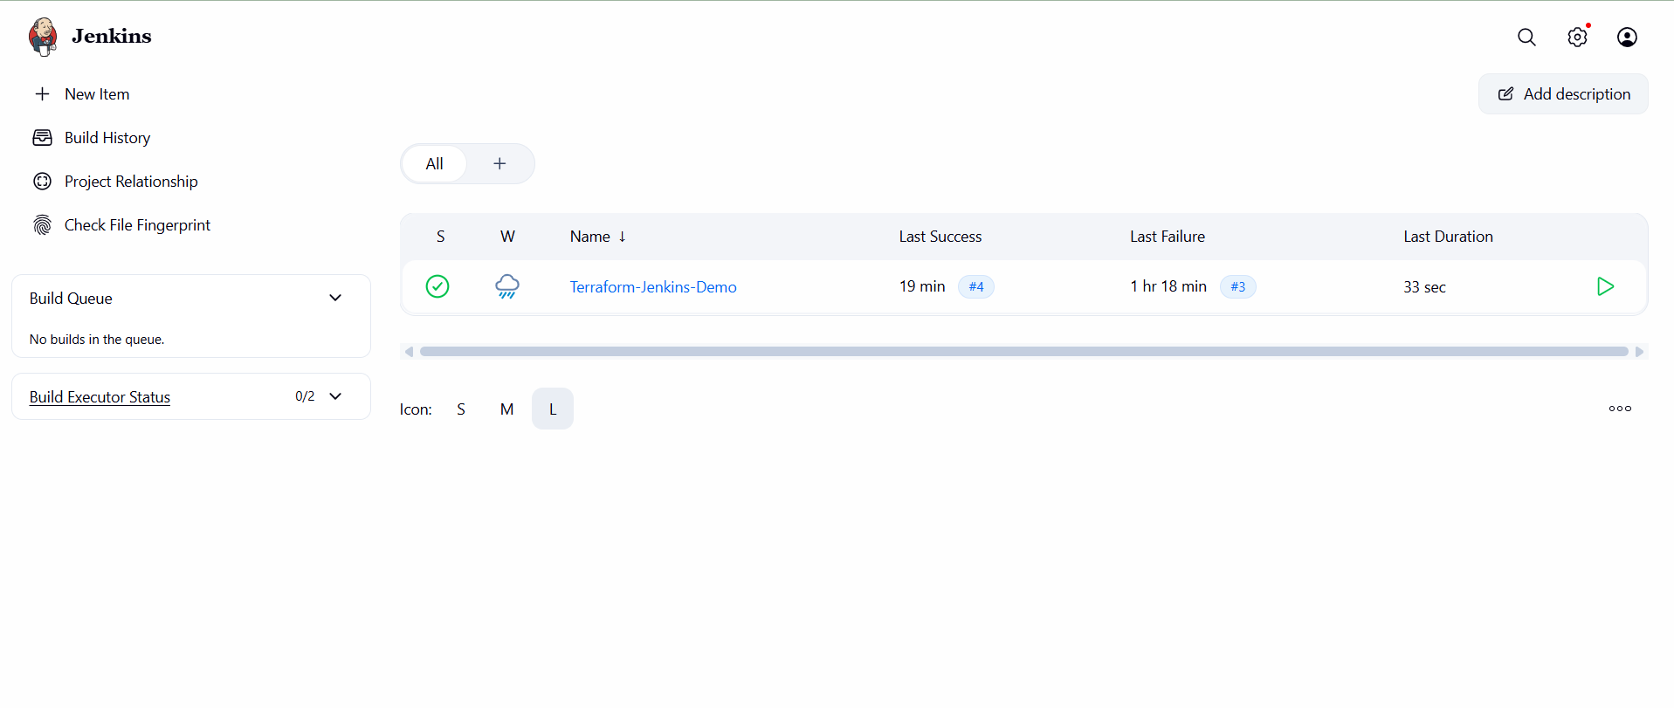

Step 4: Configure GitHub Repository

Pipeline Configuration
- Open the Terraform-Jenkins-Demo Jenkins job.
- Open Configure.
- Go to the Pipeline section.
- Set Definition to Pipeline script from SCM.
- Select Git as the SCM.
- Enter the private GitHub repository URL.
- Add GitHub credentials using the GitHub username and Personal Access Token.
- Set Branch Specifier to */main.
- Set Script Path to Jenkinsfile.
- 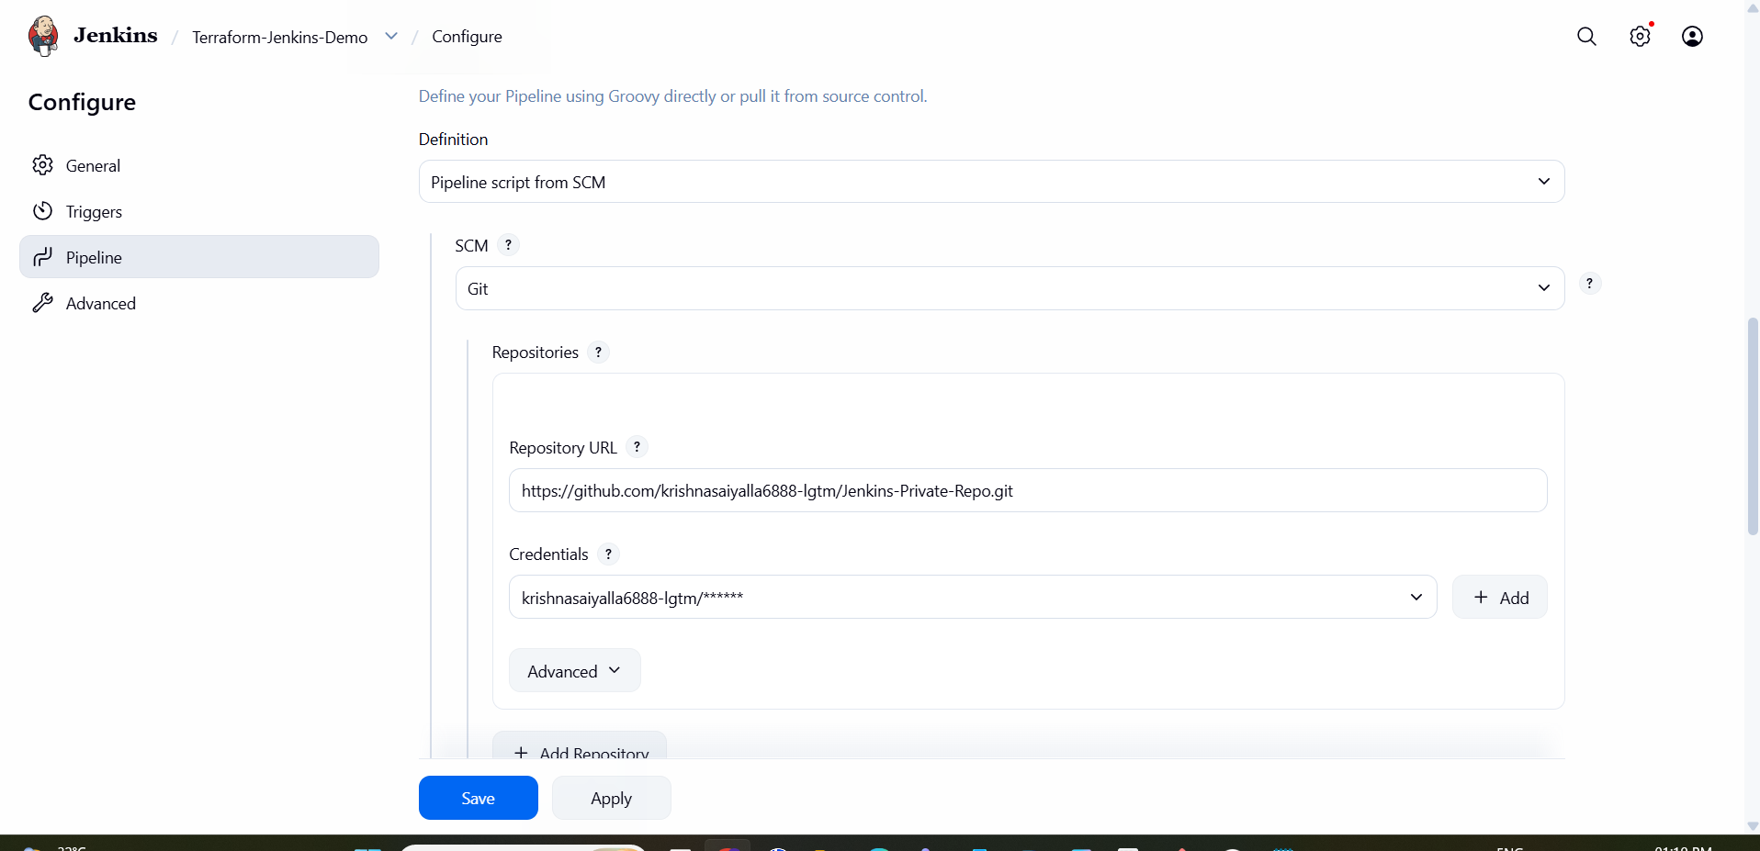
Setting | Value
SCM | Git
Repository | https://github.com/krishnasaiyalla6888-lgtm/Jenkins-Private-Repo.git
Branch | */main
Script Path | Jenkinsfile
Credentials | GitHub Personal Access Token credential

Step 5: Create Jenkinsfile

Jenkinsfile
The Jenkinsfile follows the reference pipeline and includes one additional harmless echo line used during troubleshooting.
pipeline {
agent any

stages {
stage('Terraform Init') {
steps {
sh 'terraform init'
}
}

stage('Terraform Plan') {
steps {
sh 'echo "Starting Terraform Plan..."'
sh 'terraform plan'
}
}

stage('Terraform Apply') {
steps {
sh 'terraform apply -auto-approve'
}
}
}
}

Repository Structure
Jenkins-Private-Repo/
├── .gitignore
├── .terraform.lock.hcl
├── main.tf
└── Jenkinsfile
The Terraform state file is intentionally not stored in Git.

Step 6: Run Jenkins Build

Build the Pipeline
In Jenkins:
Terraform-Jenkins-Demo
↓
Build Now
The successful build executed:
Terraform Init
↓
terraform init
↓
Terraform Plan
↓
terraform plan
↓
Terraform Apply
↓
terraform apply -auto-approve

Successful Result
No changes. Your infrastructure matches the configuration.

Apply complete! Resources: 0 added, 0 changed, 0 destroyed.

Finished: SUCCESS
The pipeline did not create a duplicate instance because the existing Terraform-created EC2 was imported into the Jenkins workspace Terraform state.
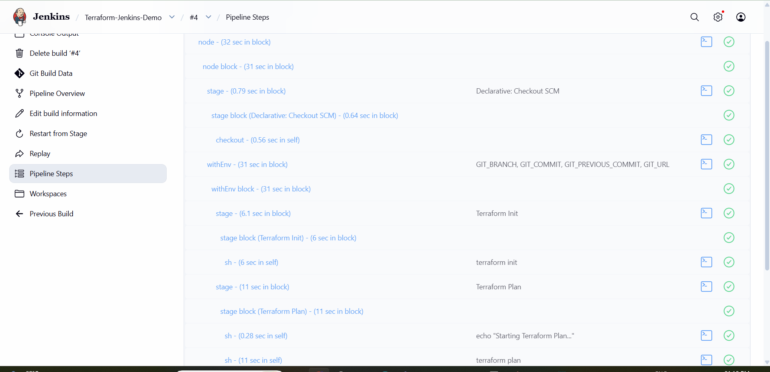

Final Jenkins Flow

Final Workflow
Developer
│
▼
GitHub
│
│ Jenkins pulls code
▼
Jenkins
│
├── terraform init
│
├── terraform plan
│
└── terraform apply
│
▼
AWS EC2
│
▼
Terraform-Jenkins-Demo

